Dear Boys and Girls!!
After a long day travelling yesterday I have finally arrived in Oviedo Northern Spain! I had a wonderful time yesterday - on the flight from Dublin to Barcelona I got to sit in the cockpit of the plane and meet the pilots!!!!
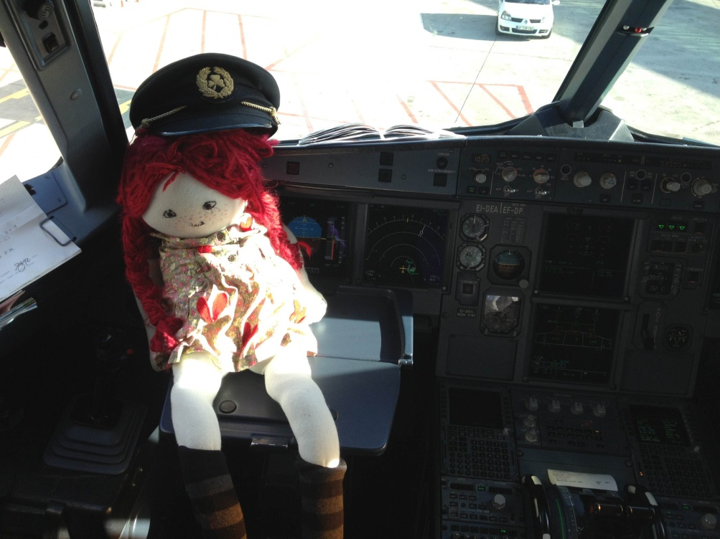

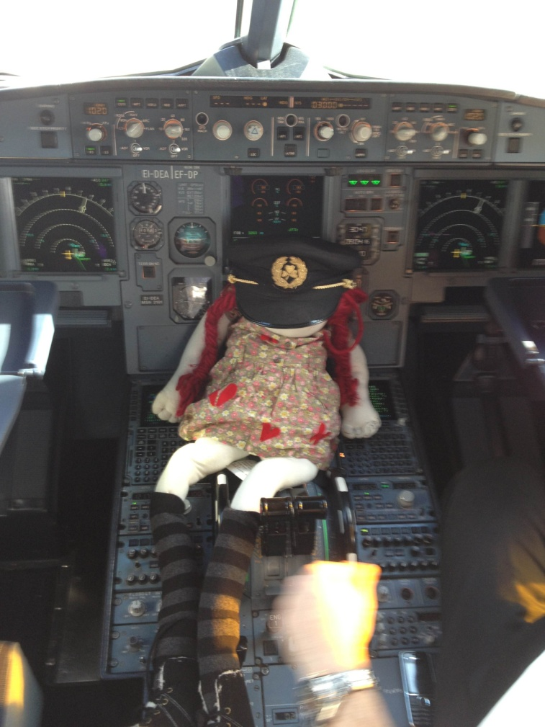
It was such an adventure! Not only were Mrs. Kelly and Ms Timoney on the flight with me but so was Elena from Room 16´s daddy!!!!
I had a few hours in Barcelona before my next flight and we took a bus from the airport into the city centre. We didn´t have a lot of time so we decided to visit a very famous building. It is called Casa Batllo and was designed by Gaudi. It is a wonderful house – all of the walls are curved and it´s like being under the sea! Here is a picture of Ms. Timoney and me on the roof!

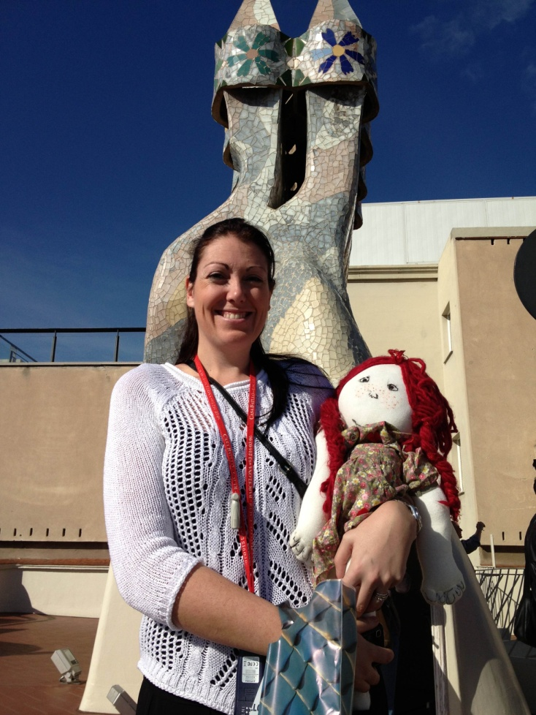

I bought a postcard of this wonderful house and have it in my suitcase to share with you all when I get back. Ask your teacher to look it up in your classroom!! It´s not like any house I´ve ever seen before!
We then flew from Barcelona to Asturias and got another bus then to Oviedo, the city where I will be staying for the next few days.
I was so tired after all the travelling I had an early night! I have just arrived to the school in Oviedo where I will be meeting lots of boys and girls! I will take some more pictures and email you all again soon!!
Adios!!!
Love Pippi, Mrs Kelly and Ms Timoney

