Dear boys and girls,
Wednesday was another very busy day for us here in Oviedo. November is still autumn in Spain and today there was a big traditional festival in the school to celebrate the harvest. This celebration is called Amaguestu.

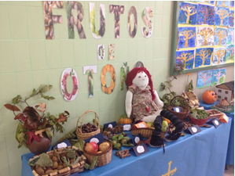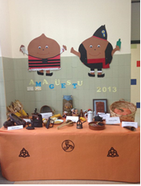

To celebrate the festival the children, myself, Ms. Timoney and Mrs. Kelly wore a blue cape with the symbol of Oviedo on it, a cross, and traditional hats. 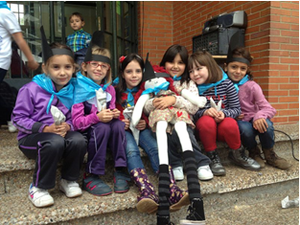

There were Asturian dancers, musicians and woodcutters at the school for the celebrations! We all got to dance and had a great time!

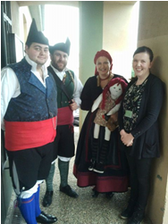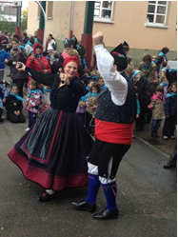
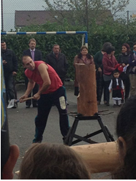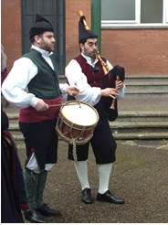

The children played lots of different traditional games.
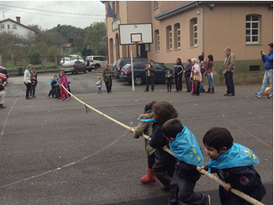
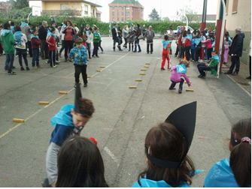
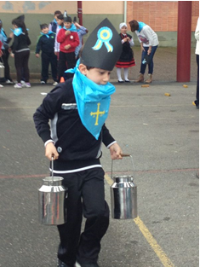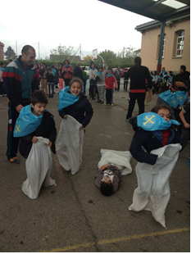

All of the boys and girls' parents were invited to the school for the day and there was a competition for the best homemade dessert! Five lucky teachers had to sit on the jury and taste ALL of the desserts and vote on the yummiest! Ms. Timoney was one of the jurors!!

There were 24 desserts in total!!! 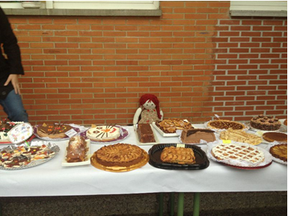

As this was a very special day in the school and for the community a regional tv station wanted to interview and meet some of the visiting teachers!! Myself and Ms. Timoney had to answer some questions about Ireland for the camera!!! I was a little bit nervous but it was great to feel famous for a little while!!
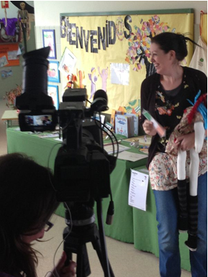
What an exciting day we had!!!

Adios
Love Pippi

